# Design Overview for RPG Adventure

Name: Tran Thanh Minh

Student ID: 103809048

# Summary of Program

**Describe what you want the program to do… one or two paragraphs.**

I want to design a RolePlay program based on Swin Adventure. It is the text-based game where the user will enter the command to play.

I also will implement the menu and monsters, …

**Include a sketch of sample output to illustrate your idea.**

# Required Roles

Describe each of the classes, interfaces, and any enumerations you will create. Use a different table to describe each role you will have, using the following table templates.

Table 1: Enemy type enumerations details

|  |  |
| --- | --- |
| Value | Notes |
| Monster | For class Monster |
| Boss | For class Boss |

Table 2: interface IspecialAbilityUser details

|  |  |  |
| --- | --- | --- |
| Responsibility | Type Details | Notes |
| Can generate the powerful attack | Print out text |  |

Table 3: abstract Enemy class details

|  |  |  |
| --- | --- | --- |
| Responsibility | Type Details | Notes |
| Declare the public variables for the stats of the Enemy | Parameter : string name, int health, int attack , int defense, int gold, int exp | default |
| Take damage(int hurt) | Type : void  Parameter : int hurt | Reduce the current health |
| IsDeath() | Type : bool  Return true || false | Check whenever the enemy is dead or not |
| Enemyinfo() | Type: public  Return string | Return all the information of the enemy |

Table 4: abstract EnemyWithSpecialAbility details – duplicate

|  |  |  |
| --- | --- | --- |
| Responsibility | Type Details | Notes |
| UseSpecialAbility() | Type: void |  |
| EnemyWithSpecialAbility | Default  Public and inherited from Enemy | Default inherited from Enemy and use the Ispecialabilityuser |

Table 5: public abstract Enemy details

|  |  |  |
| --- | --- | --- |
| Responsibility | Type Details | Notes |
| Name | Return string  Public | Public property |
| Health | Return int  Public | Public property |
| Attack | Return int  Public | Public property |
| Defense | Return int  Public | Public property |
| MaxHealth | Return int  Public | Public property |
| Gold | Return int  Public | Public property |
| Expgain | Return int  Public | Public property |
| Enemy() | Parameters (string name, int health, int attack, int defense, int gold,int exp) | Default constructor |
| TakeDamage() | Parameter: int hurt  Public  Type: void | Decrease the amount of health for the enemy |
| IsDeath() | Public  Return bool | Check if the enemy’s health is below 0 or not |
| EnemyInfo() | Public  Return string | Print out the current info of the boss |

Table 6: Action details

|  |  |  |
| --- | --- | --- |
| Responsibility | Type Details | Notes |
| Attack() | Type: public static void  Parameters: player, enemy | Attack the enemy |
| Defend() | Type: public static void  Parameters: player, enemy | Defend against the enemy |
| Heal() | Type: public static void  Parameters: player, enemy | Heal the player |
| EnemyAttack() | Type: public static void  Parameters: player, enemy | Enemy attack |
| checkExp() | Type: public static void  Parameters: player | Check if exp is enough to level up |
| LevelUp | Type: public static void  Parameters: player | Level up the player |

Table 7: Boss details

|  |  |  |
| --- | --- | --- |
| Responsibility | Type Details | Notes |
| Boss() | Type: public | Default constructor and inherited form the EnemyWithSpecialAbility |
| UseSpecialAbility() | Type: public override void | Print out the skills |

Table : Program details

|  |  |  |
| --- | --- | --- |
| Responsibility | Type Details | Notes |
| Main() | Type: public static void  Parameter: string[] args | Main program, print out the title of the game and run the program |

Table 8: GamePlay details

|  |  |  |
| --- | --- | --- |
| Responsibility | Type Details | Notes |
| InitStates() | Type: private void | Create new states and push new mainmenu state |
| InitPlayer() | Type: private void | Create new playerlist |
| End | Type: private  Return End |  |
| Initial() | Type: private void | Set the end to false |
| GamePlayer() | Type: public | Default constructors and includes other Inits methods. |
| Run() | Type: public void | Keep the states keep updating. If there is no states, exit the program. |

Table 9: State details

|  |  |  |
| --- | --- | --- |
| Responsibility | Type Details | Notes |
| State() | Parameters: stack<state> states | Default constructor |
| wantEnd() | Type: public bool  Return bool | For exit the menu |
| Update() | Type: public virtual void |  |

Table 10: Main menu state details

|  |  |  |
| --- | --- | --- |
| Responsibility | Type Details | Notes |
| MainMenuState() | Type: public  Parameters: Stack<State> states, ArrayList playerlist | Default constructors to set the local variables to equal to the parameters |
| Process() | Type: private void  Parameter: string num | For the menu to decide on the input of the user |
| Update() | Type: public override void | Keep update the menu state |
| NewGame() | Type: private void | Process when player choose new game |
| Choose player() | Type: private void | To set the currentplayer for later use. |

Table 11: Player State details

|  |  |  |
| --- | --- | --- |
| Responsibility | Type Details | Notes |
| PlayerState() | Type: public  Parameters: Stack<State> states, Player player | Default constructor to set the local variables to equal to the parameters |
| Process() | Type: private void  Parameter: string num | For process the input choice |
| CreatePlayer() | Type: private void | For create new player |
| EditPlayer() | Type: private void | For edit the stats of player |
| Rename() | Type: private void |  |
| GetNewValue() | Type: private  Return string  Parameters: string message, string currentvalue | For get a new name |
| GetNewLevel() | Type: private int  Parameter: string message  Return int | For getting experience for leveling up |
| DeletePlayer() | Type: private void | For deleting player in arraylist |
| Update() | Type: public override void | For printing out the menu for the player |

Table 2: GameState details

|  |  |  |
| --- | --- | --- |
| Responsibility | Type Details | Notes |
| GameState() | Type: public  Parameters: Stack<State> states, Player currentplayer | Default constructor to set the local variables to the parameters |
| Process() | Type: private void  Parameter(string num) | Process based on the input |
| Update() | Type: public override void | Printing out the menu content for the current state |
| Story() | Type: private static void  Parameter: player player | Printing out the story |

Table 3: SceneState details

|  |  |  |
| --- | --- | --- |
| Responsibility | Type Details | Notes |
| SceneState() | Type: public  Parameters: Stack<State> states, Player player | Default constructor |
| Process | Type: private void  Parameter: string num | Input menu choice |
| Update() | Type: public override void | Keep updating method |
| Displayshop() | Type: private void  Parameter: Player currentp | Include the ShopInstructions and SaveShop |
| ShopInstruction() | Type: private void | Print out shop content |
| SaveShop() | Type: private void  Parameter: Player player | Call the Buy depend on the input of the user |
| Buy() | Type: private static void  Parameters: string item, int cost, Player player | Check if the user’s coin is enough |
| Equipment() | Type: private static void  Parameters: Player player |  |

Table 4: EnemyState details

|  |  |  |
| --- | --- | --- |
| Responsibility | Type Details | Notes |
| EnemyState() | Type: public | Default constructor |
| Process | Type: private void  Parameter: string num | Input menu choice |
| Update() | Type: public override void | Keep updating method |
| Run() | Type: private void | If choice was run |
| DeathFlag() | Type: private void | If the player health is return 0 |

Table 5: Program details

|  |  |  |
| --- | --- | --- |
| Responsibility | Type Details | Notes |
| Main | Type: public static void  Parameter: string[] args | Main program |

Table 6: Player details

|  |  |  |
| --- | --- | --- |
| Responsibility | Type Details | Notes |
| Player() | Type: public  Parameters: string namein, string descrip | Default constructor |
| Stats() | Type: private void | Set the initial value |
| Exp | Type: public  Return int | Property |
| MaxExp | Type: public  Return int | Property |
| Health | Type: public  Return int | Property |
| MaxHealth | Type: public  Return int | Property |
| Name | Type: public  Return string | Print out the name and desc |
| NamePlayer | Type: public  Return string | Property |
| Descplayer | Type: public  Return string | Property |
| Level | Type: public  Return int | Property |
| Defend | Type: public  Return int | Property |
| Potion | Type: public  Return int | Property |
| Gold | Type: public  Return int | Property |
| Damage | Type: public  Return int | Property |
| DamageMax | Type: public  Return int | Property |
| Weapon | Type: public  Return string | Property |
| WeaponDmg | Type: public  Return int | Property |
| Banner() | Type: public  Return string | Display player info |
| ToString() | Type: public override  Return string | Display player info |
| AllInfo() | Type: public  Return string | Display player full info |
| Win() | Type: public void  Parameter: Enemy enemy | If the player win |
| TakeDamage() | Type: public void  Parameter: int damage | If the player take damage |
| UseHeal() | Type: public void | If the player use potion to heal |
| IsDefending | Type: public  Return bool | If the player is defend or not |

Table 7: Monster details

|  |  |  |
| --- | --- | --- |
| Responsibility | Type Details | Notes |
| Monster | Type: public | Default constructor |

Table 8: GUI details

|  |  |  |
| --- | --- | --- |
| Responsibility | Type Details | Notes |
| Title() | Type: public static void  Parameter: string title |  |
| Menu() | Type: public static void  Parameters: string num, string text |  |
| ProgressBar() | Type: public static  Parameters: int min, int max, int width |  |
| SystemNoti() | Type: public static void  Parameter: string text |  |
| GetCommand() | Type: public static void  Parameter: string input |  |
| GetCommandCount() | Type: public static  Parameter: string input  Return string |  |
| GetCommandInt() | Type: public static  Parameter: int input  Return int |  |
| Slowprint() | Type: public static void  Parameter: string text |  |
| Congrat() | Type: public static void  Parameter: string text |  |
| WaitEnter() | Type: public static void |  |

# Class Diagram

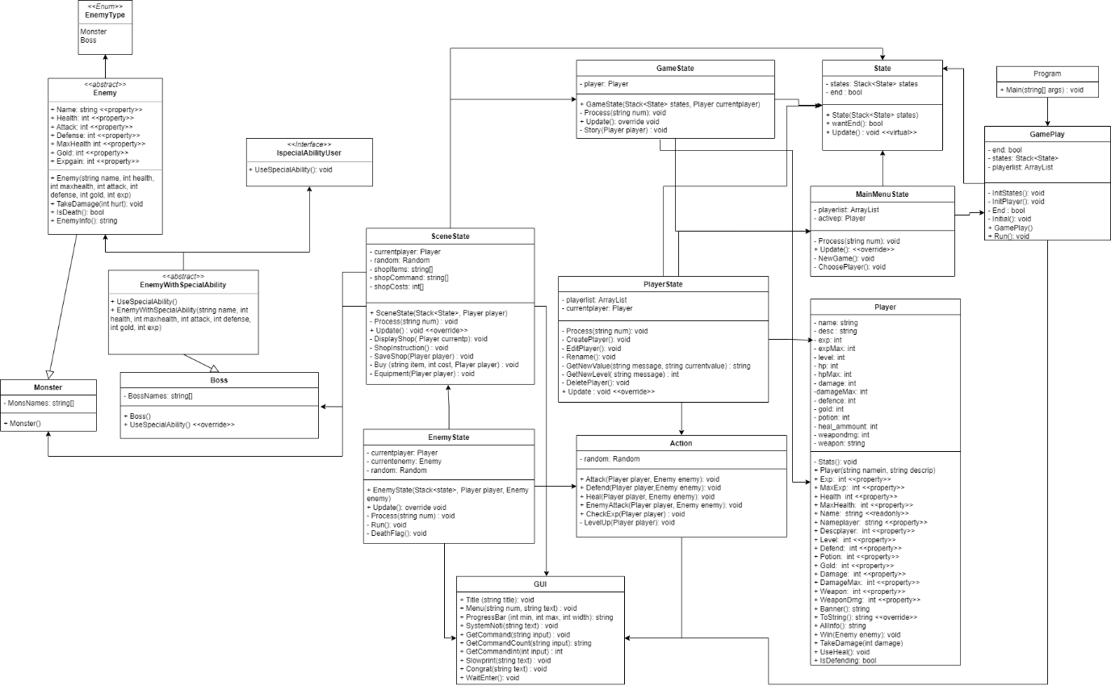

# Sequence Diagram

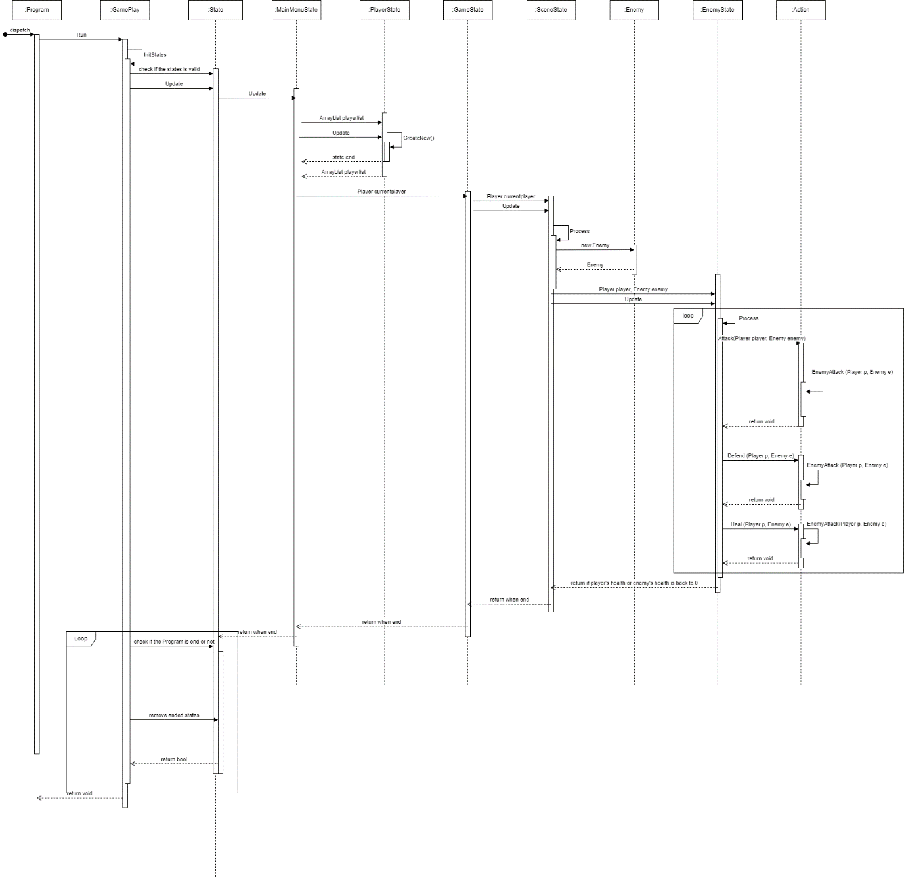

# The output of the Program

Because I focus on the functions of the program so its appearance may not beauty.

Image 1: Main Menu

This is the main menu where first we run the program. Depend on the option that we select, the program will create the menu for that flow.

Image 2: Trying to create a new game

If the user hasn’t selected any player then the new game option cannot be chosen.

Image 3: Create new player

After creating the player, I can edit or delete it easily.

Image 4: After selecting Player

Image 5: Enter the game menu

Image 5: Player stats

Image 6: Storyline to introduce the game

Image 7: Encountered monster

Image 8: Attack monster

Image 9: when end the program